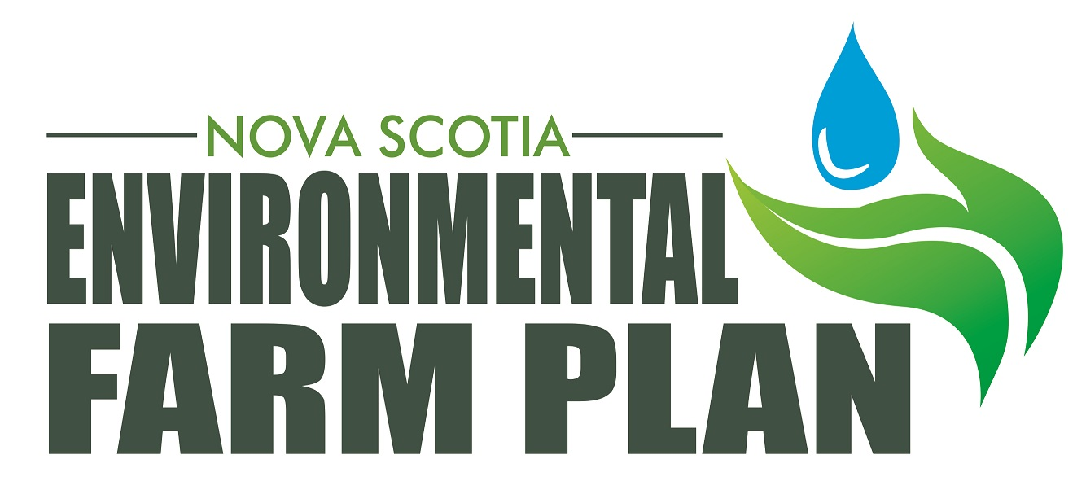
Nova Scotia Environmental Farm Plan Follow-up
Comments Form

This comments form is directed to participants that have received a copy of their Follow-up report. The goal is to assess farmer satisfaction with the program and to determine possible program improvements. Your participation is greatly appreciated.

1) Do you feel that the EFP follow-up process was useful?
- Yes
- No

2) The follow-up process is much more focused on previously identified risks and does not involve a thorough review of the farm. Would you like the follow-up process to be conducted differently?

3) Did the EFP follow-up meet your expectations?
- Yes
- No
- Better

4) How often do you feel that a follow-up should be done?

5) Would you like the Agricultural Engineer to be a part of the follow-up?

6) Which resources did you find useful?
  - Field cropping record book
  - Factsheets
  - EFP Follow-up Report
  - EFP Coordinator
  - Water Sample Testing

7) Do you feel that it would be beneficial if the EFP program were to include other agricultural issues such as energy conservation and alternatives or health and safety?

8) Would you like to be recognized for completing an Environmental Farm Plan? If yes, in what way would you like to be recognized?
- Farm Gate Sign
- Completion Certificate
- More Public Awareness
- Other _____________________________

9) How would you prefer any further follow-up processes to be conducted?
- Visit to the Farm
- Through a Workshop
- Filling in a Workbook on your own time
- Further follow-ups are not necessary

10) Would it be okay to use your comments for promotional purposes?
- Yes
- No

If yes, please provide your name ________________________

Thank you for taking the time to complete the comments form.

Contact Information: Any comments, questions or concerns can be directed to Jillian Saulnier

FPP/NSFA Office
Telephone: 893-2293
Fax: 893-7063
jsaulnier@nfsa-fane.ca

